# **Day 23 Task**

**Objective:** Participants will create a custom AWS IAM policy that meets a specific condition: allowing access to a designated S3 bucket only for a particular IAM role, without including conditions. They will then estimate the cost for deploying a multi-tier architecture solution using AWS Pricing Calculator.

## **Part 1: Implementing a Custom IAM Policy for S3 Access**

**Scenario:** You have a scenario where a development team needs access to an S3 bucket containing logs generated by an application. Only a specific IAM role, "DevTeamRole," should have permission to list and read objects in this bucket, while no other actions should be allowed. The participants will implement this policy to meet this requirement.

**Steps:**

* Understand the Requirements:
  + Review the scenario where only the "DevTeamRole" is allowed to access the S3 bucket named application-logs.
  + The policy should only permit s3:ListBucket and s3:GetObject actions on this bucket.

First Created a S3 bucket with name **shital-application-logs**

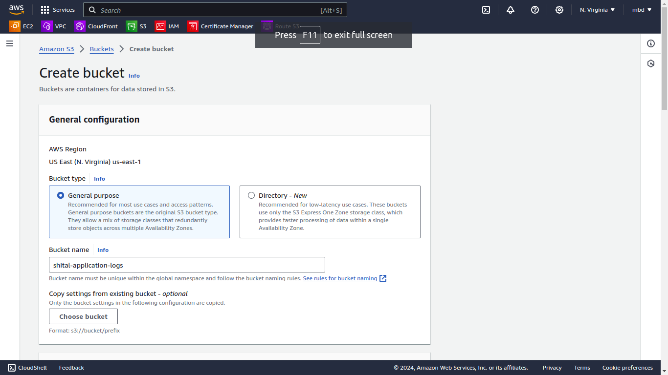

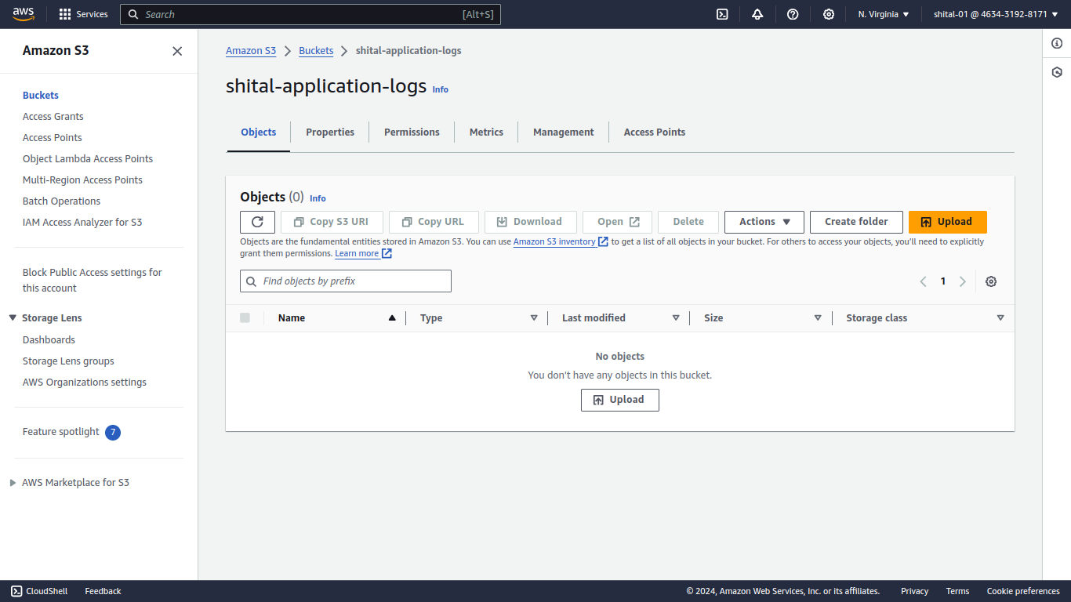

* Create a New IAM Policy:
  + Navigate to the IAM console and create a new custom policy.
  + Define the policy to allow s3:ListBucket and s3:GetObject actions.
  + Specify the ARN of the application-logs bucket and any specific objects within the bucket as resources.

Then Created a new IAM policy with required S3 bucket json policy given below

{

"Version": "2012-10-17",

"Statement": [

{

"Effect": "Allow",

"Action": [

"s3:ListBucket"

],

"Resource": "arn:aws:s3:::shital-application-logs"

},

{

"Effect": "Allow",

"Action": [

"s3:GetObject"

],

"Resource": "arn:aws:s3:::shital-application-logs/*"

}

]

}

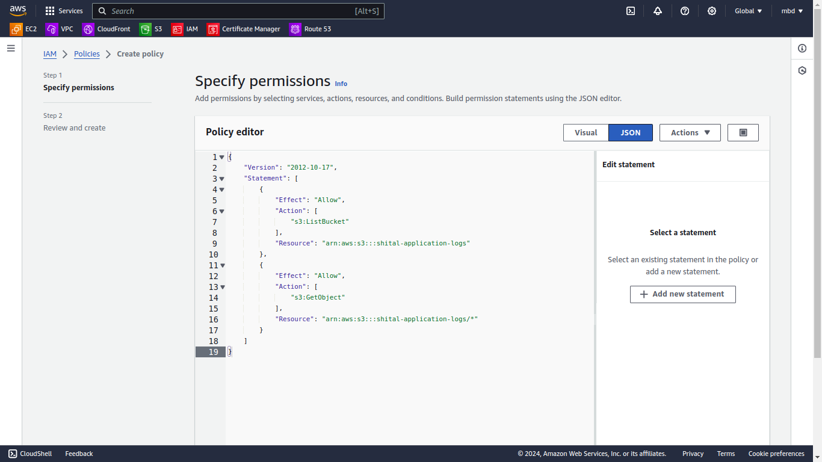

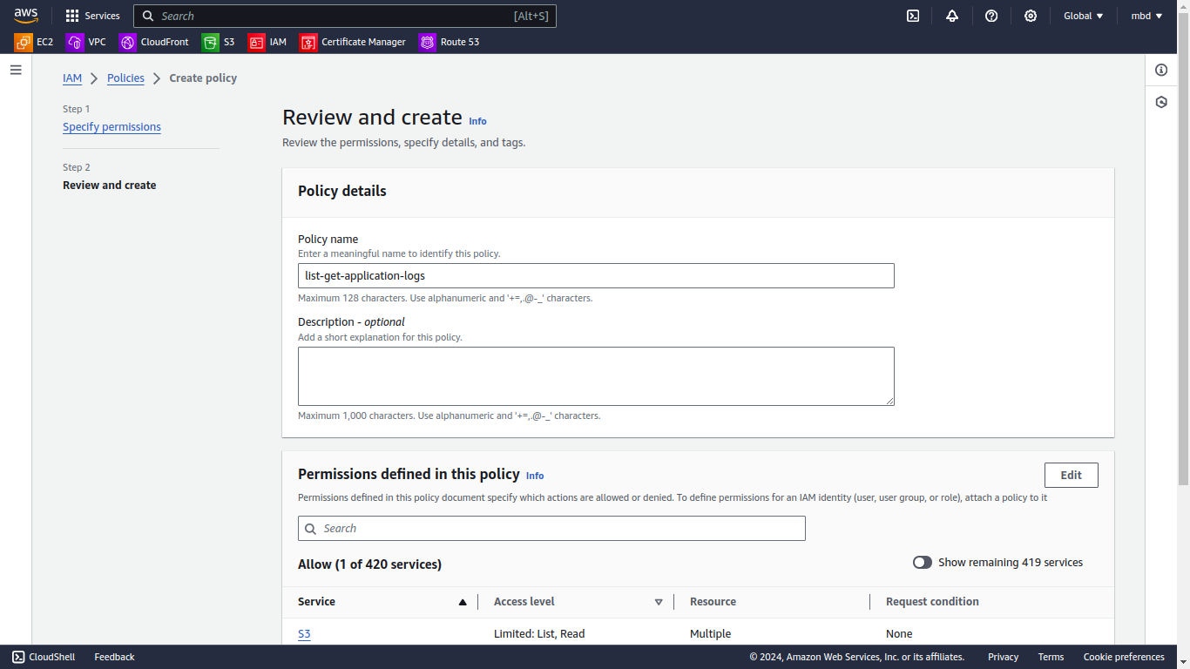

* Attach the Policy to the IAM Role:
  + Attach the custom policy to the "DevTeamRole" role.
  + Ensure that no other users or roles are granted access to this bucket by this policy.

Created a new IAM Role **DevTeamRole** and attached policy to it

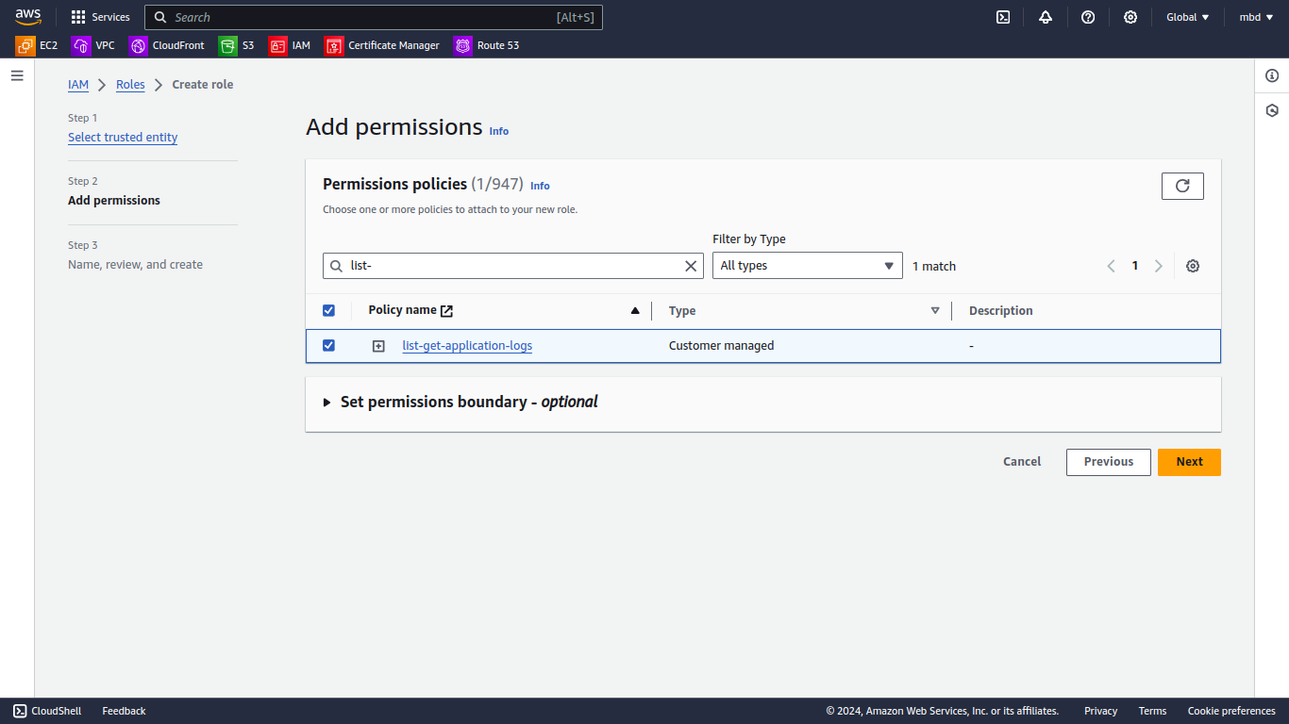

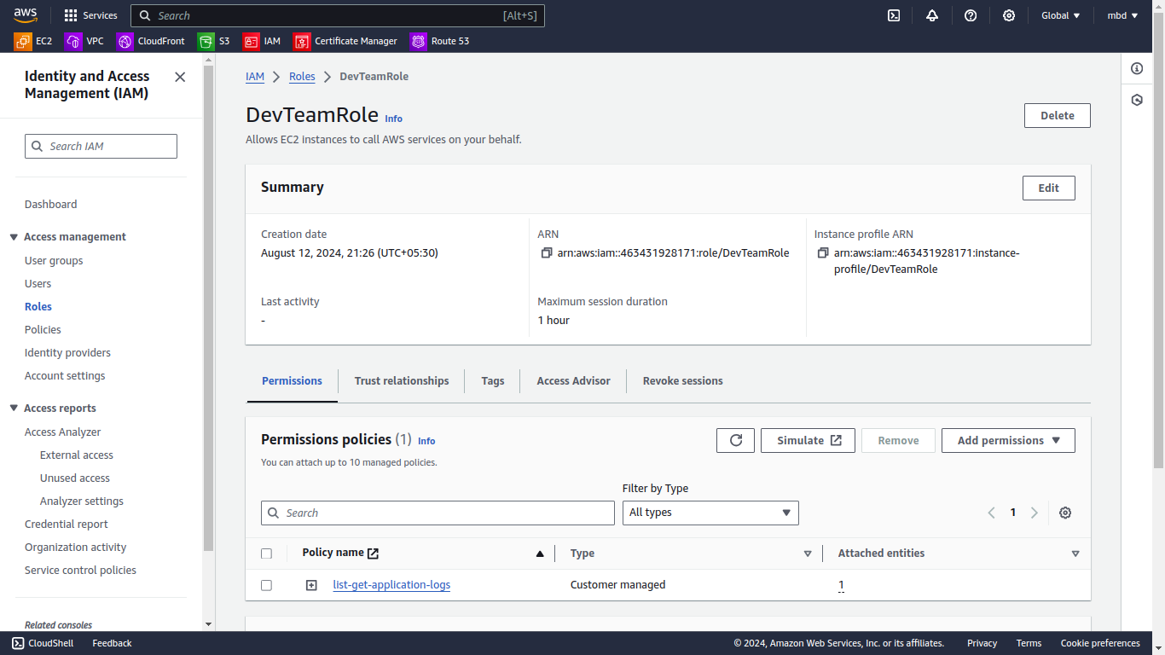

* Test the Policy:
  + Attempt to access the S3 bucket using the "DevTeamRole" to ensure only the allowed actions (list and read) are permitted.
  + Document the results of the test, ensuring that actions outside of the allowed scope (e.g., delete, write) are correctly denied.

**Able to list and read the S3 Bucket**

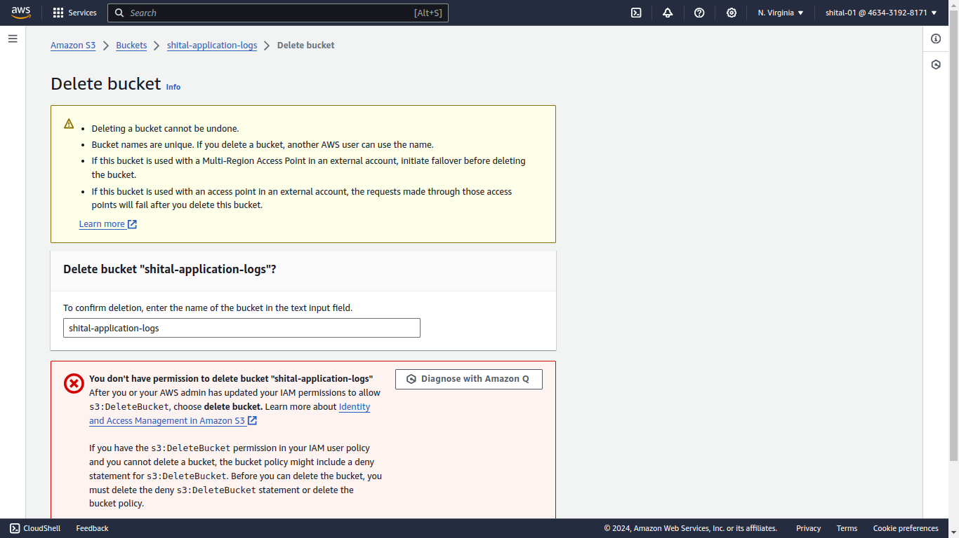

**Unable to delete and write the S3 Bucket**

